

**Artificial Intelligence**

**Chess Programming**

**Assignment Report**

**Submitted by:**

|  |  |  |
| --- | --- | --- |
| **Name** | **Roll-Number** | **Section** |
| Muhammad Abdullah | L164156 | C |
| Hammad Iklaq | L16xxxxx | C |

**Submitted to:**

**Dr. Mirza Mubasher Baig**

**Evaluation Functions And their Strategies**

We have seen various evaluation functions and their strategies. Functionality of three of them are described below.

* Rob Upcrafts Evaluation function.
* Jazz(jazz and sjaal) Evaluation function.
* David Cline Evaluation function.

**Rob Upcraft’s Evaluation function:**

Rob upcraft’s evaluation function works similar to Alan turing’s evaluation function as it is based on it. Some of the modifications that he made to alan turing’s function is the implementation of mobility pawn advancment and piece safety along with the alteration of piece weights.

**Comparison Between weights of These two evaluation function**

|  |  |  |
| --- | --- | --- |
| **Piece name** | **Alan turing’s weight** | **Rob upcraft’s weight** |
| Pawn | 100 | 100 |
| Knight | 300 | 300 |
| Bishop | 350 | 350 |
| Rook | 500 | 500 |
| Queen | 1000 | 900 |

**Rob’s Modifications:**

The two major modifications that rob made are piece safety and pawn advancment.

**Piece safety:**

In a board state after a move, its value is increased by 1/30th of its original value for every piece that is not under threat by the enemy.

**Pawn advancement:**

As having more advanced pawns is an advantage in the game for every rank that is advanced by a pawn it gains four point value.

**Rob’s Approach:**

Rob uses minimax approach in his evaluation function in which white maximizes the evaluation function while black minimizes the evaluation function. As illustrated by the figure given below:

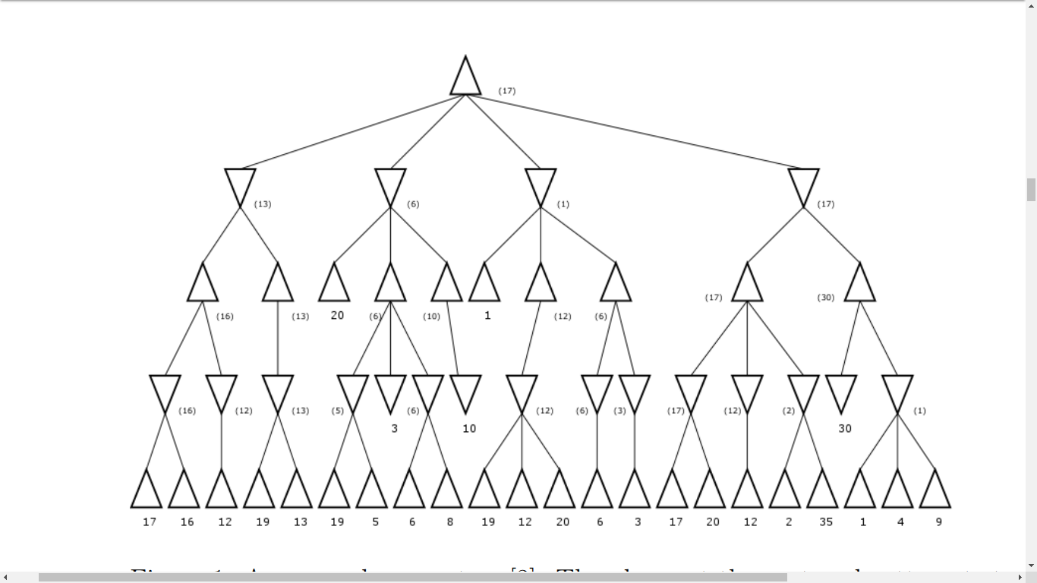Rob also uses parallelization in which the task is divided and distributed into diferent microprocessers to enhance accuracy by going through greater depth.

**Jazz Evaluation Function:**

Jazz evaluation function works by dividing the evaluation into to major portions.

* **Dynamic Evaluation.**
* **Static Evaluation.**

**Dynamic Evaluation:**

The issue with static evaluation is that it does not check about the dynamic threats (hanging pieces,forking,discovered check). As for forking and dynamic check, they are hard to check to check and will make the algorithm very complicated and time taking, hence losing its value. So dynamic evaluation only checks for hanging pieces and does not consider static evaluation on the board state containing friendly hanging pieces.

**Static Evaluation:**

The static evaluation Is then applied on the filtered board states, comparing material matching, pawn structure evaluation, mobility, piece square tables of: knights, bishops, rooks and king’s safety(safety, not check!).

**Material matching:**

The comparison of materials of both sides by assigning weights to different pieces and also by giving a bonus if both the knight,bishop or rooks are alive.

**Pawn structure evaluation:**

Pawn structure evaluation checks for the pawn advancement or any possible doubling of pawns.

**Piece square evaluation:**

Piece square evaluation assign different values to the pieces depending on the blocks they are placed by taking into account the complex characteristics of piece positioning, the effect of pawn structure and such factors like distance from enemy king.

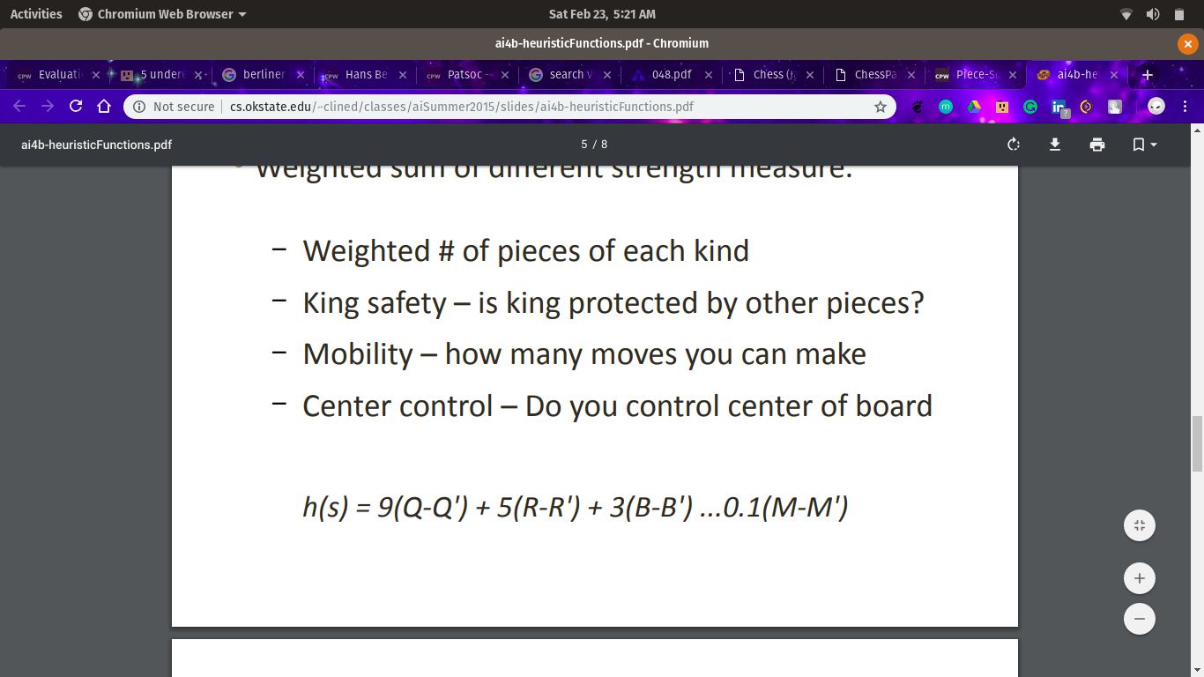

**King safety:**

king safety is evaluated by the factors such as the distance from enemy pieces, friendly pieces and the possible openings or threats to the king.

**David Cline’s Evaluation function:**

David Cline’s evaluation function uses heuristic function on known terminal nodes to stop the recursion because in alpha-beta pruning, the search tree grows deeper. The heuristic function used by this evaluation function is:

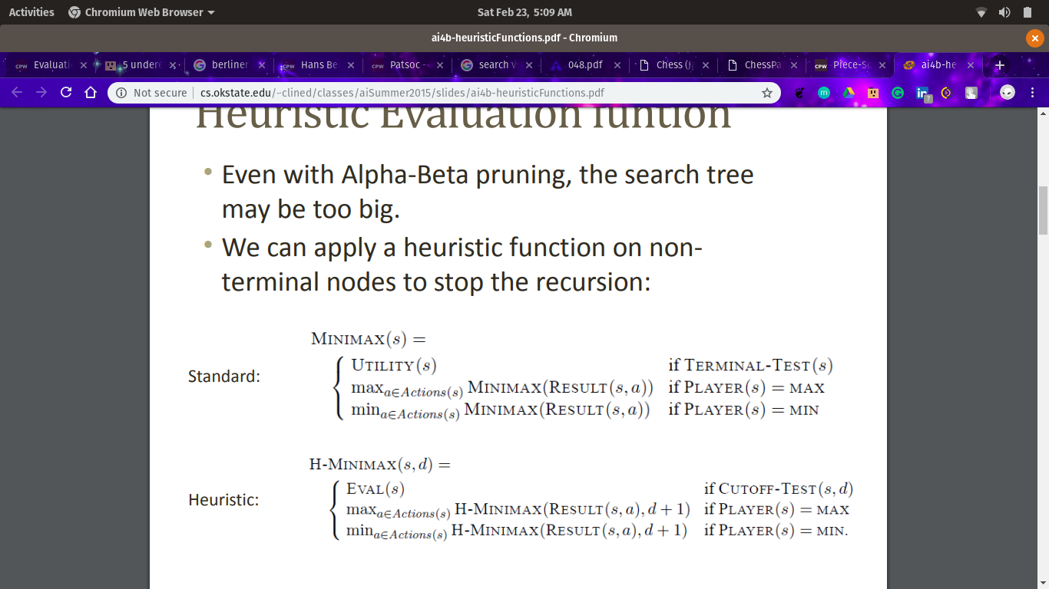

The main purspose of using heuristic approach is to estimate the goodness of a position in minimax search without actually expanding the tree to the leaf nodes.

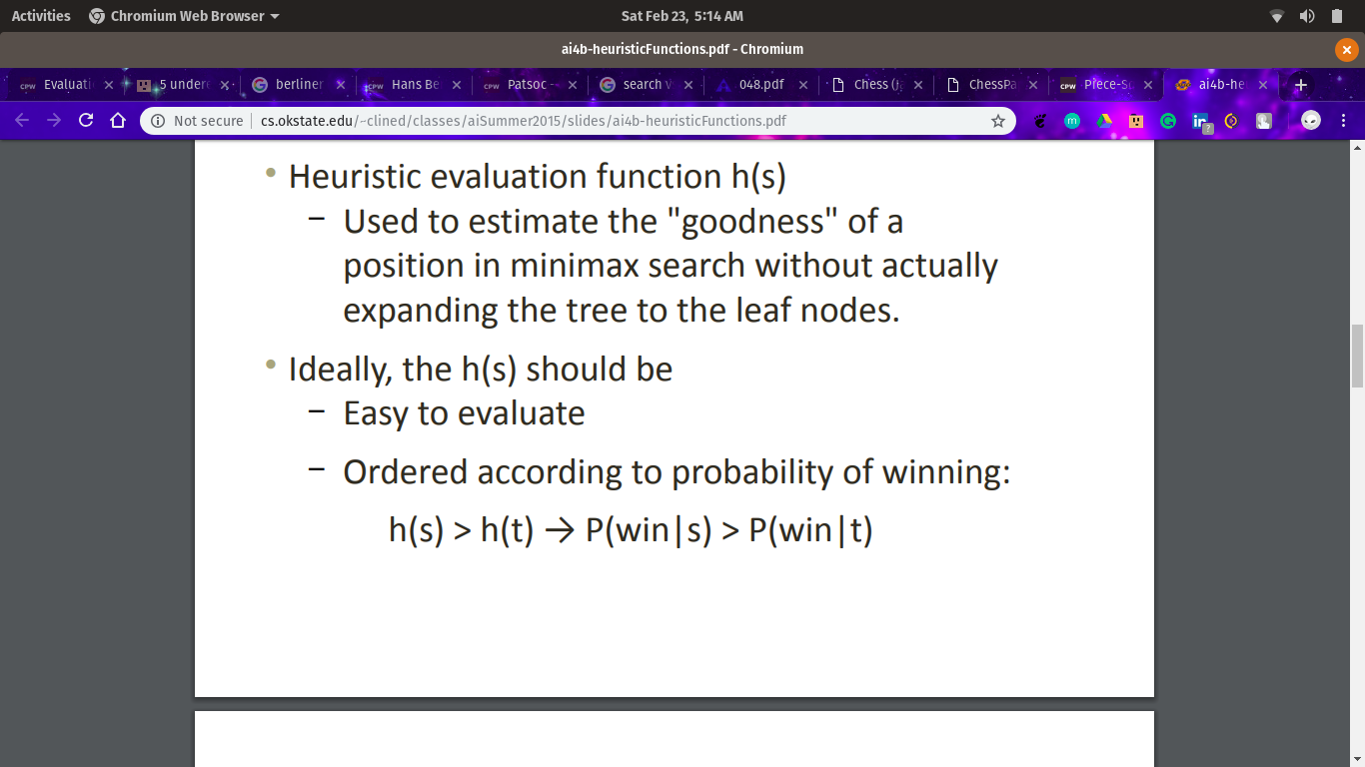

**Strategy used by David:**

* **Weighted sum of different strength measure:   
  →** Weighted number of pieces of each kind.  
  → King Safety: Is king protected by other pieces.  
  → Mobility: How many legal moves can be made?  
  → Center Control: How much of the center is in your control.
* 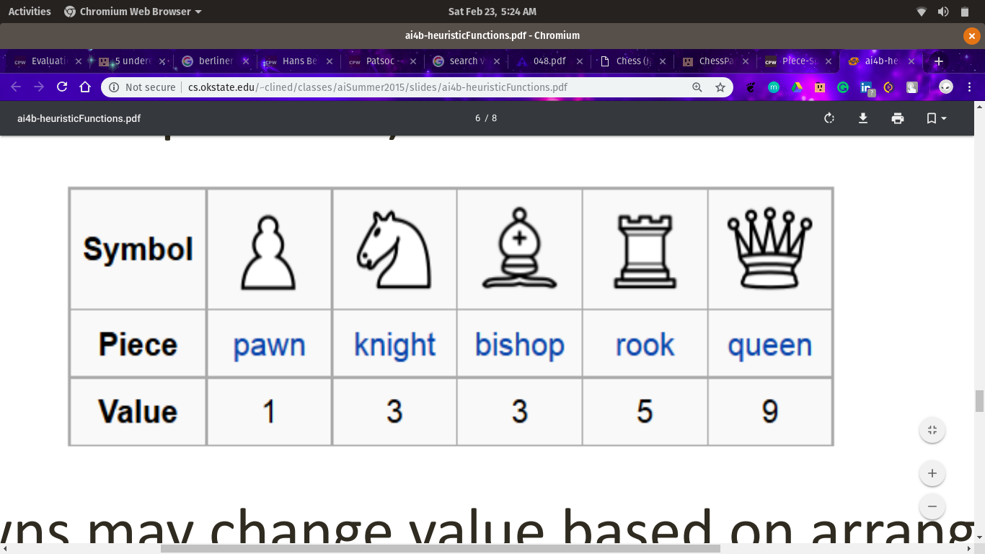**Standard Piece Weights:**This standard piece weightage may be modified based on the paw structure and current stage of the game.

**References:**

*Rob Upcraft:*

<http://robupcraft.com/files/projects/ChessPaper.pdf>

*Jazz:*

<http://www.eglebbk.dds.nl/program/chess-eval.html>

*David Cline:*

<http://cs.okstate.edu/~clined/classes/aiSummer2015/slides/ai4b-heuristicFunctions.pdf>